Summary of Work – Eitan Asher

Hi Jan and Ronny, here is the work I've done so far with the synchronization with a cross-modulation method on the EEG data.  
  
Part 1

In this part I had to reproduce the figures in Jan's article –



The results I got are –

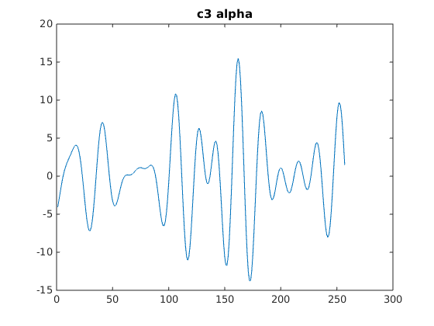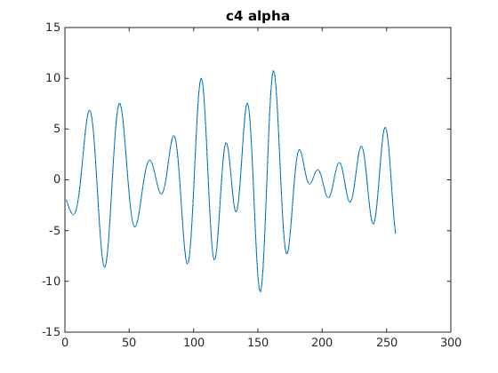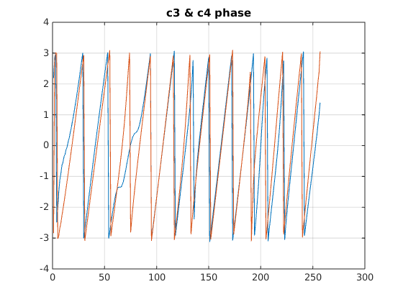

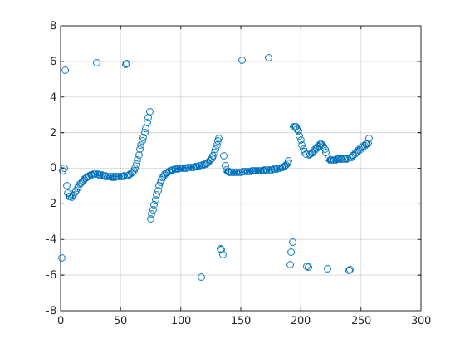

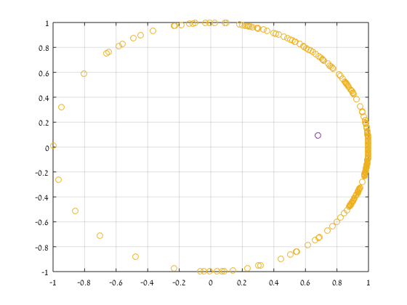

The results are pretty similar to the paper.  
The only difference I saw was in gamma.

In the paper, gamma is said to be 0.38, although one can see with the eye that the magnitude is larger than 0.6.  
My result was gamma of 0.68.  
  
  
Part 2

In Part 2, I had to calculate the amplitude phase difference between two signals, with a second Hilbert transform. I'm not quite sure that it was successful, because I did not get a similar result to the one in the paper.

Here are the results from the paper –



I wanted to reproduce the wave in figure e, which is the amplitude phase difference between the signals. This is what I got when comparing two signals, alpha and delta1 waves taken from the same period of time –

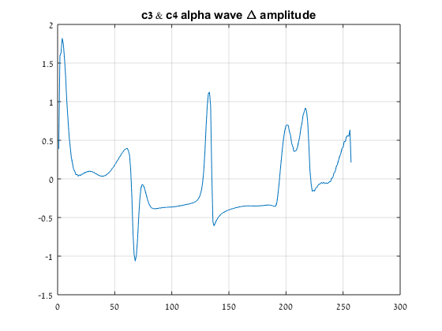

You can clearly see that it oscillates much more than the one in the figure.

\*I will also attach my code so you can check it if you have time.

Next, we want to build the network, either from the EEG electrodes or from the brain waves.  
In order to do that, we need to find a threshold of gamma, which will determine if two nodes have a connection between them.

Thus I used surrogate data, to find the distribution of gamma.

I took different electrodes in different times (randomly chosen), each segment 1 second long and calculated gamma for it.

This is the histogram I got –

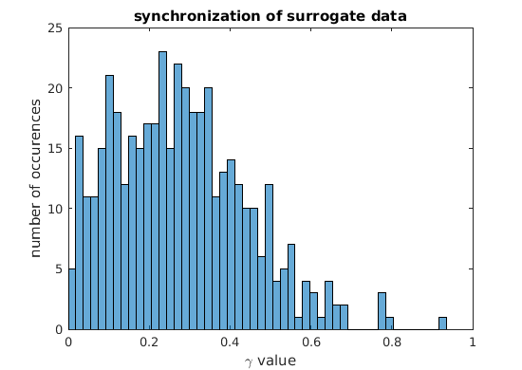

Average = 0.27

It's worth mentioning that when calculating gamma for the same signal , I got gamma = 1.

Let me know what you think. I will be waiting for instructions how to proceed.

Looking forward to hearing from you,   
Eitan